

Case Study Report

**Tech Saksham**

Data Analytics with Power BI

**“360-degree Business Analysis of Online Delivery Apps using Power BI”**

**“**V.O.Chidambaram College**”**

|  |  |
| --- | --- |
| **NM ID** | **NAME** |
| 8C375AE0AF54821B8984176A55F5E6E4 | S. PAVITHRA |

**Trainer Name:** R.Uma Maheshwari

**Master Name:** Uma Maheswari

**ABSTRACT**

The purpose of this thesis is to build an online food ordering app. It provides information, menus, and user reviews of restaurants as well as food delivery options from partner restaurants in select cities .Our research also includes the “satisfication of consumers by using online food services”. It will deal with consumer behaviour and helpd to analyse the perception. Online payment makes this process more easier and faster.

**INDEX**

|  |  |  |
| --- | --- | --- |
| **Sr. No.** | **Table of Contents** | **Page No.** |
| 1 | Chapter 1: Introduction | 4 |
| 2 | Chapter 2: Services and Tools Required | 6 |
| 3 | Chapter 3: Project Architecture | 7 |
| 4 | Chapter 4: Modeling and Result | 9 |
| 5 | Conclusion | 18 |
| 6 | Future Scope | 19 |
| 7 | References | 20 |
| 8 | Links | 21 |

**CHAPTER 1**

**INTRODUCTION**

* 1. **Problem Statement**

To design an enhanced food delivery system and experience for customers such that they get a better experience right from the ordering stage to food delivery and the after service.

How might we develop a solution which improves the customer experience in such a way that there is transparency between the customers and the restaurants ,they get to know the nutritional value to keep track of the fitness and also have easy access to healthy food options?

* 1. **Proposed Solution**

The design problems were identified after conducting the Research, Interviews and Observations. Allows customers to order any item that they like and adjust the quantity of the food item .Offering an enthralling delivery experience may be challenging and complicated to design an implement.If you can do so ,you will have an advantage over your competitors. So , use a feature-rich delivery management system to overcome all your problems.

* 1. **Feature**
* FOOD ORDERING: Allowing the users to order their food on-the-go from two different restaurants.
* NO MINIMUM ORDER: The customer does not have to a minimum amount to order from a restaurant .
* EXPLORE PLACES: Offering the discovery and guide to the user for exploring nearby restaurants with pictures, reviews and map locations.
* ONLINE PAYMENTS: Online payments facilitate the flow of the money in the right direction, a step forward to corruption-free India.
  1. **Advantages**
* Opened 24/7.
* Save time and money.
* Reduce costs.
* Hits the target market.
* Online delivery mechanism.
* Food can be ordered from multiple sources.
  1. **Scope**

Users are diverting towards healthy food options and the people who stay alone want more affordable home-cooked food options as their food choice.Users want to stay fit and also track their nutritional intake.

Users want more transparency between themselves and the restaurants in terms of knowing their cooking methods/kitchen cleanliness and hygiene and the quality of integredients being used for food preparation.Difficulty in cooking food at home mostly because of lack of time.

**CHAPTER 2**

**SERVICES AND TOOLS REQUIRED**

**2.1 Services Used**

**Data Integration Services:** Services for data integration are crucial for collecting and consolidating data from various sources transactional databases, customer feedback platforms, delivery tracking systems and market research databases .Tools like Microsoft Power automate, Azure Data Factory and third party Services like zapier can be used for seamless data integration .

**Data Warehousing:** Storing and organizing data efficiently is essential for performing analytics effectively. Data Warehousing Services Azure synapse Analytics and Amazon Red shift can be used to store large volume of structured and unstructured data for analysis .

**Cloud storage:** Cloud storage solution like Azure Blob storage and Amazon S3 can be used to store raw data, intermediate data and processed dataset securely, making it accessible for analysis by Power BI and other tools.

**Machine Learning Services:** Azure Machine Learning or AWS Sage Maker can be used to build predictive models based on historical data.

**2.2 Tools and Software used**

**Tools**:

* **PowerBI**: The main tool for this project is PowerBI, which will be used to create interactive dashboards for real-time data visualization.
* **Power Query**: This is a data connection technology that enables you to discover, connect, combine, and refine data across a wide variety of sources.

**Software Requirements**:

* **PowerBI Desktop**: This is a Windows application that you can use to create reports and publish them to PowerBI.
* **PowerBI Service**: This is an online SaaS (Software as a Service) service that you use to publish reports, create new dashboards, and share insights.
* **PowerBI Mobile**: This is a mobile application that you can use to access your reports and dashboards on the go.

**CHAPTER 3**

**PROJECT ARCHITECTURE**

**3.1 Architecture**



|  |  |  |
| --- | --- | --- |
|  |  |  |

Here’s a high-level architechture for the project:

**Front-end web or mobile application:** This is the interface customers use to generate menus,browse menus, place orders and delivery status.

**Backend server are services:** This component handles requests from the frond end, communicates with the databases, and coordinates with delivery partners.

**Database:** This stores information about menus, orders, customers and delivery partners.

**API Gateway:** This is responsible for request routing, composition and protocol translation among other things between an application and the set of micro services.

**Messaging Queue:** An asynchronous communication between systems that allows multiple systems to send and receive messages reliably and efficiently without needing to be constantly connected.

**Notification Service:** To send notifications to users, typically through email or push notifications.

**Tracking Engine:** This will constantly watch for changes in the DB, update the elastic search index, and notify the messaging queue.

**CHAPTER 4**

**MODELING AND RESULT**

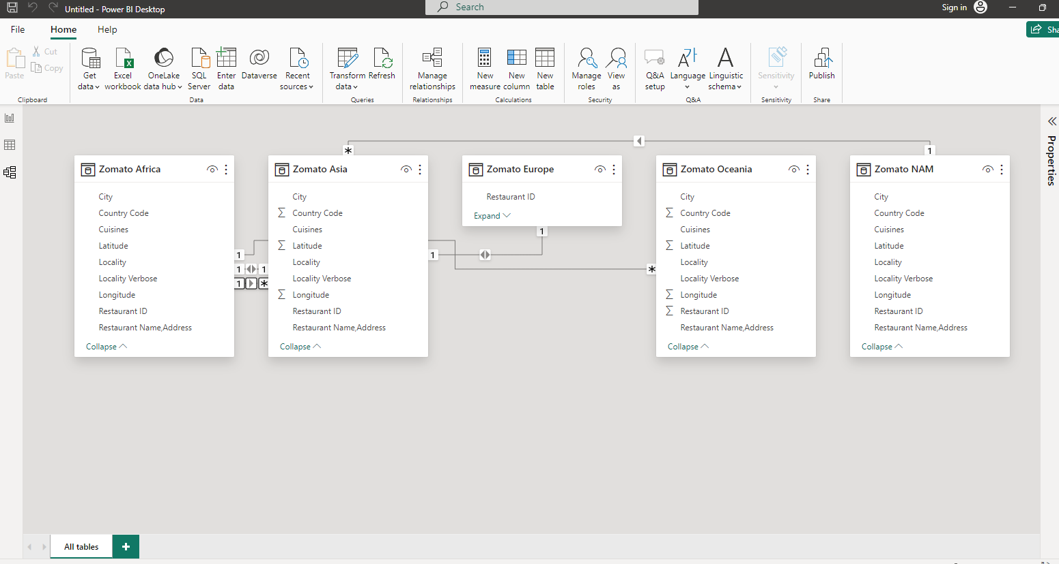

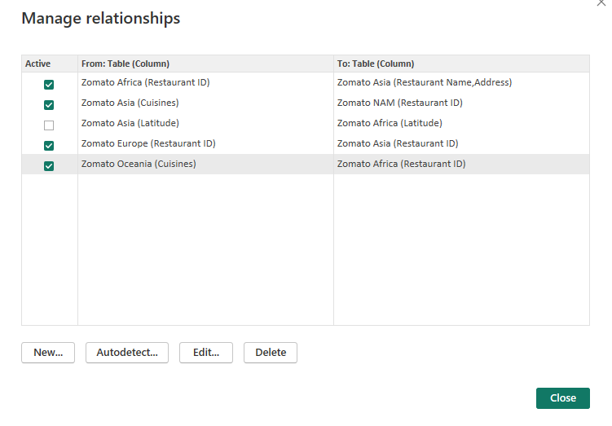

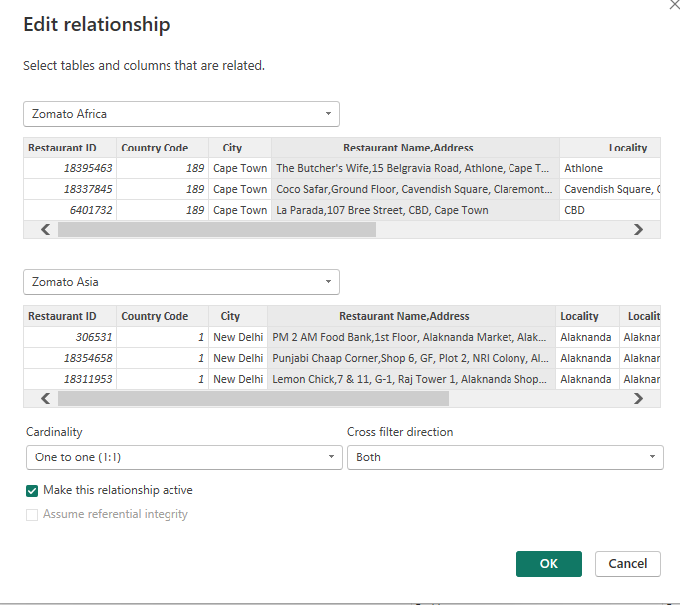

**Dashboard**

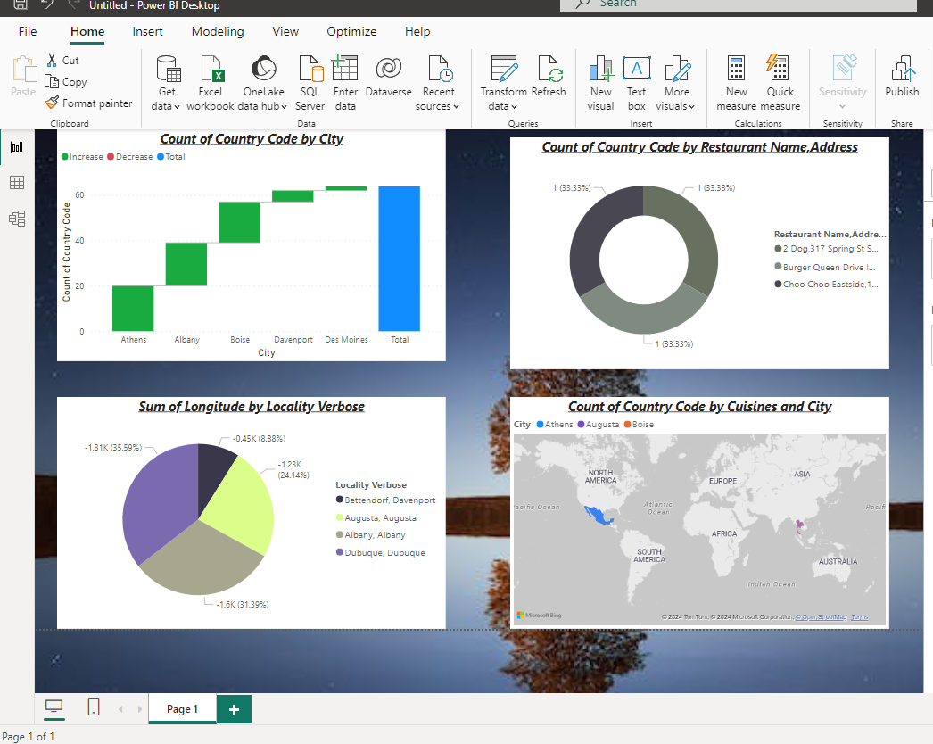

**CONCLUSION**

Nowadays the traditional way of going to a restaurant and eating has reduced considerable.It’s a new age where technology dominates human life. With the software and technological devices, exceptions are reduced and even terminated.Also people prefer easy, quick and save access to everything.With this platform we developed, we are hoping to reduce time wasting, avoid misunderstanding, customer pleasure and less hard work.

The online food ordering system provides a simple way to store details of the customer, Food items available and to generate the bill.

**FUTURE SCOPE**

The Online Food Delivery market in India is projected to reach a revenue of US$43.78bn in 2024.

It is expected to show an annual growth rate(CACR 2024-2028) of 16.95%.This growth will result in a projected market volume of US$81.91bn by 2028.In the Grocery Delivery market in India,revenue is expected to grow by 30.7% in 2025.In the Meal Delivery Market in India,the number of users is expected to reach 346.6m users by 2028.India’s online delivery market is experiencing rapid growth due to the increasing demand for convenience and the wide range of cuisines available.

**REFERENCES**

<https://bootcamp.uxdesign.cc/ux-case-study-online-food-delivery-aac10a67d2e>

**LINK**